Grade 7 Accelerated · Unit 3  Reference Sheet  Exponents and Scientific Notation — keep this in your binder | Name______________________  Date______________________  Period____________________

Everything on this page is tested from memory. The Grade 8 FAST reference sheet does not list the laws of exponents or anything about scientific notation; what it gives you is an on-screen scientific calculator, and a calculator shows very large and very small numbers in the E form described in section 4.
1. The Laws of Exponents Lessons 1–3, 6–7 · know all seven cold
Every law comes from writing the powers out. . If you forget a law, expand and count.
Law | Rule | Example
Product of powers | 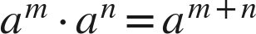 | 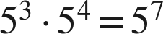
Quotient of powers | 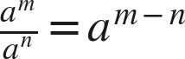 | 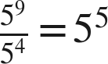
Power of a power | 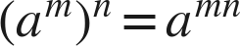 | 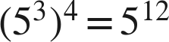
Power of a product | 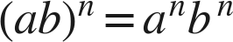 | 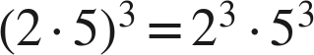
Power of a quotient | 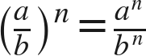 | 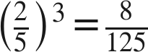
Zero exponent | 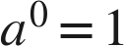 (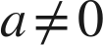) | 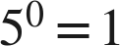, 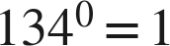
Negative exponent | 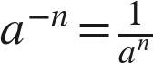 () | 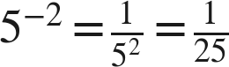

The laws only combine LIKE bases. 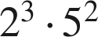 cannot be written as one power. 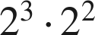 can.
Add or subtract exponents when you multiply or divide. Multiply exponents for a power of a power. The bases never change: is 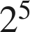, never 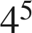 and never 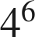.
Order of operations still applies. Powers before multiplication; parentheses first. 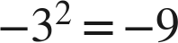 but 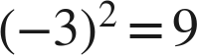. 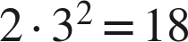, not 36.
2. Zero and Negative Exponents Lessons 2, 4, 5
The pattern that explains both. Each step to the right divides by 2:
 | 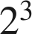 | 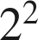 | 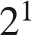 | 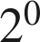 | 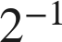 | 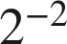 | 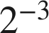
16 | 8 | 4 | 2 | 1

A zero exponent gives 1, not 0. Any nonzero base. 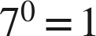 and 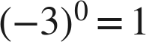 and 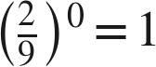.
A negative exponent means RECIPROCAL, never a negative value. 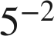 is 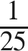, a small positive number. It is not 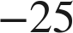 and it is not . Reciprocal (flip it) and opposite (change the sign) are different words.
The base keeps its own sign. 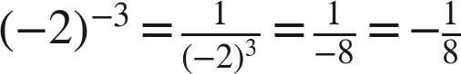. The minus in the answer came from the base, not from the exponent.
A negative exponent in a denominator moves up. 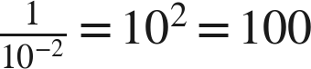.
A fraction base with a negative exponent flips. 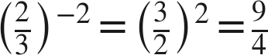.
Working backwards. 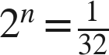 means 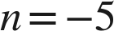, because 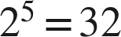.  means 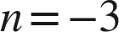.
3. Variable Bases Thread A, days 1–2
Same laws, letters for bases. A monomial is a coefficient times variables with exponents: 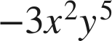. Multiply the coefficients; add the exponents of each variable separately.
Multiply | Raise to a power | Divide
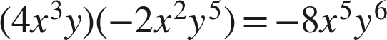 | 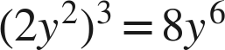 | 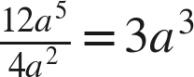
coefficients multiply; exponents add | EVERY factor is raised — the 2 as well | coefficients divide; exponents subtract

Negative exponents on variables: only the factor wearing the negative exponent moves. 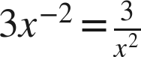, not 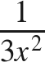. 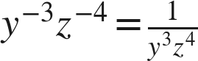. 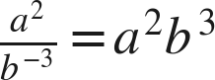.
Finish with positive exponents. 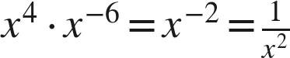. 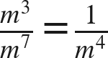.
Reciprocal pairs. 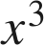 and 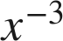 are reciprocals: when 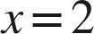 they are 8 and . Their product is 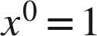.
4. Scientific Notation Lessons 8–9
Definition. A number written as , where the coefficient is at least 1 and less than 10 and is an integer. One nonzero digit in front of the decimal point — that is the whole rule. 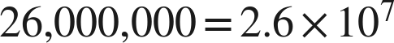 and 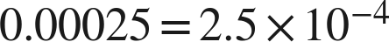.
 | Large number (10 or more) | Small number (less than 1)
Exponent | positive: the place of the first digit | negative: the decimal place of the first nonzero digit
Rule of thumb | count how many places the point moves LEFT to sit after the first digit | count how many places the point moves RIGHT to sit after the first nonzero digit
Example | 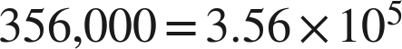 (five places) | (five places)
Reading back | 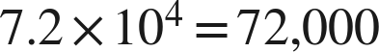

The exponent counts PLACES, not zeros. 0.0000672 has four zeros after the point, and the exponent is −5 because the 6 is in the fifth place. 356,000 has three zeros and the exponent is 5.
Equal in value is not the same as scientific notation. 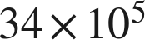 equals 3,400,000, but it is not scientific notation, because 34 is not less than 10. The correct form is 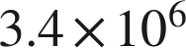.
On a calculator screen, E means × 10 to a power. 3.5E9 is . 4.2E−6 is . E is not an error message.
Which is greater? Compare the exponents first; the larger exponent wins. Compare the coefficients only when the exponents tie. 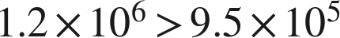. For small numbers the same rule holds: because −5 > −8.
5. How Many Times Larger or Smaller Lessons 8–9
Divide the coefficients. Divide the powers of 10 (subtract the exponents). Multiply the two results.
Case | Example | Answer
Same power of 10 | 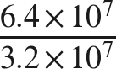 | times
Same coefficient | 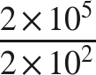 |  times — not 3
Both different | 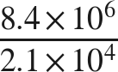 |  times
Negative exponents | 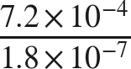 |  times; −4 − (−7) = 3
Large against small | 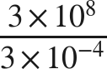 | 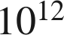 times; 8 − (−4) = 12

A thousand, not three. 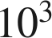 times larger is a THOUSAND times larger. The exponent is not the answer; the power is.
'Times smaller' is the same division read the other way. If A is 4,000 times larger than B, then B is 4,000 times smaller than A.
6. Vocabulary
base — the number or variable being multiplied by itself: in 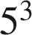 the base is 5
exponent — the number of times the base is used as a factor: in the exponent is 3
power — a base with an exponent: is a power; its value is 125
reciprocal — the number that multiplies a given number to give 1: the reciprocal of 8 is ; a negative exponent asks for one
opposite — the number the same distance from 0 on the other side: the opposite of 8 is −8; a negative exponent never asks for one
monomial — a number, a variable, or a product of a number and variables with whole-number exponents: , ,
coefficient — the number factor of a monomial (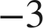 in ); in scientific notation, the factor in
like bases — powers of the same base:  and 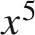; the laws combine only like bases
scientific notation — a number written as with  and an integer
standard form — a number written out with all of its digits: 26,000,000 or 0.00025
power of 10 — : for positive, a 1 followed by zeros; for negative, a 1 in the th decimal place

